NATIONAL INSTITUTE OF TECHNOLOGY KARNATAKA SURATHKAL

DEPARTMENT OF INFORMATION TECHNOLOGY

IT 301 Parallel Computing LAB 3

10th August 2021

Faculty: Dr. Geetha V

---------------------------------------------------------------------------------------------------------------------

**NAME:BHUVANESWAR DHARMASIVAM**

**ROLL NO: 191IT107**

Execute following programs and put screen shots of the output. Write analysis of the result before uploading in IRIS as a single pdf file**. For programming exercises, write the code and also attach screenshot of the results.**

**Total Marks : 10**

**1. Demonstration of reduction clause in parallel directive. Write your observation. [2 marks]**

#include<stdio.h>

#include<omp.h>

void main()

{

int x=0;

**#pragma omp parallel num_threads(6) reduction(+:x)**

{

int id=omp_get_thread_num();

int threads=omp_get_num_threads();

x=x+1;

printf("Hi from %d\n value of x : %d\n",id,x);

}

printf("Final x:%d\n",x);

}

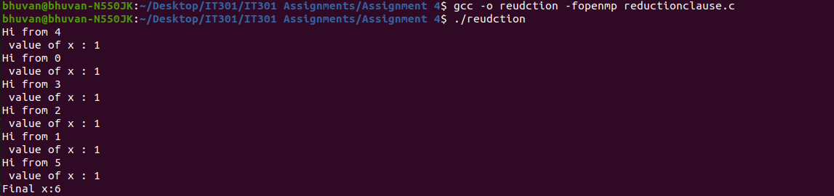Observation: The reduction operator is ‘+’ so at each thread 1 is added and final sum would be 6.

**2. Demonstration of lastprivate(). Write your observation [2 marks]**

#include<stdio.h>

#include<omp.h>

void main()

{ int x=0,i,n;

printf("Enter the value of n");

scanf("%d",&n);

#pragma omp parallel

{

int id=omp_get_thread_num();

**#pragma omp for lastprivate(i)**

for(i=0;i<n;i++)

{

printf("Thread %d: value of i : %d\n",id,i);

x=x+i;

printf("Thread %d: x is %d\n",id,x);

}

}

printf("x is %d\n",x);

printf("i IS %d\n",i);

}

E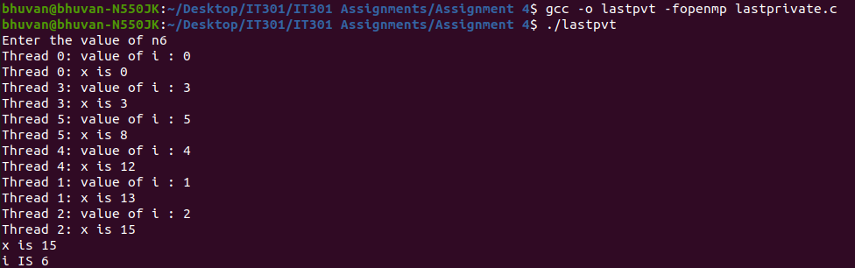xplanation: The last value inside the parallel block will displayed.

**3. Demonstration of reduction clause with ‘for’ [2 marks]**

#include<stdio.h>

#include<omp.h>

void main(void)

{

int n=20,dsum=0,tid,a[20],sum=0;

for(i=0;i<n;i++)

{

a[i]=i;

dsum=dsum+i;

}

**#pragma omp parallel num_threads(6)**

{

int tid=omp_get_thread_num();

**#pragma omp for private(i) schedule(static,5) reduction(+,sum)**

for(i=0;i<n;i++)

sum=sum+a[i];

}

printf("sum= %d\n",sum);

}

return 0;

}

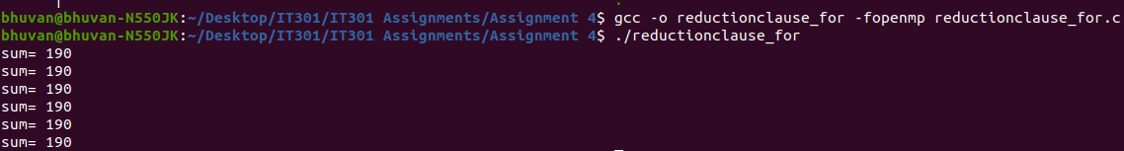Observation: The reduction operator is ‘+’ so at each thread each array element is added and final sum would be 190.

**3. Programming exercise [ 4Marks]**

**Write a parallel program to find the minimum number in a given array. Use ‘for’ directive for the same along with reduction clause. Write code, execution results and your observation.**

CODE:

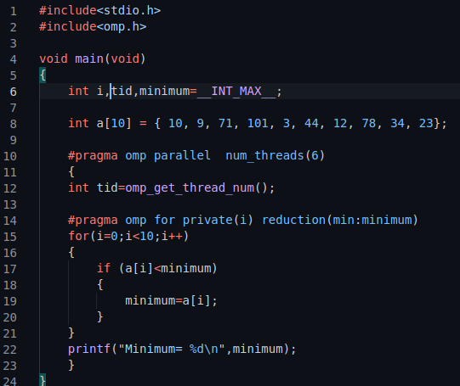

RESULT:

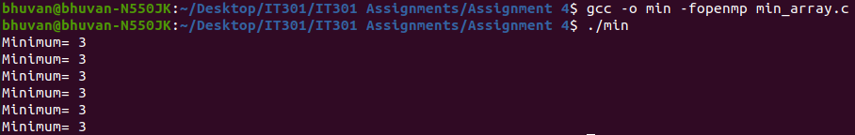Observation: The reduction operator is ‘MIN’ so at each thread array elements are compared to find minimum element.